Apache Ignite HelloWorld

1. 下载并安装ignite

*wget http://mirror.bit.edu.cn/apache//ignite/2.5.0/apache-ignite-fabric-2.5.0-bin.zip*

1. 解压并设置环境变量

*unzip apache-ignite-fabric-2.5.0-bin.zip*

设置环境变量~/.bashrc

e*xport IGNITE_HOME=/root/soft/apache-ignite-fabric-2.5.0-bin*

*export PATH="$IGNITE_HOME/bin:$PATH"*

1. 启动Ignite

*bin/ignite.sh examples/config/example-ignite.xml*

启动信息如下：

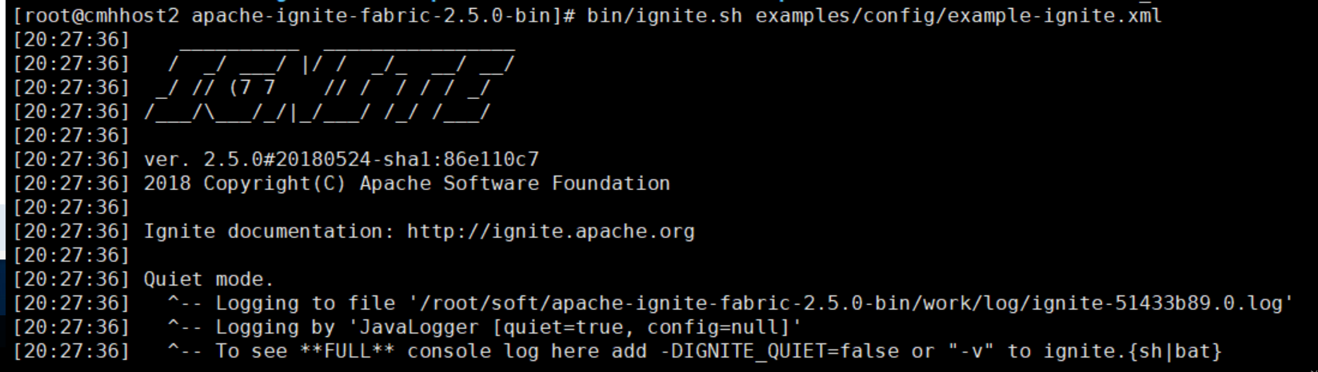

1. 编写测试程序

*public class HelloWorld {*

*public static void main(String[] args) {*

*try( Ignite ignite = Ignition.start("example-ignite.xml")) {*

*IgniteCache<Integer,String> cache = ignite.getOrCreateCache("myCache");*

*cache.put(1,"Hello");*

*cache.put(2,"World!");*

*ignite.compute().broadcast(() -> {*

*String hello = cache.get(1);*

*String world = cache.get(2);*

*System.out.println(hello + " " + world);*

*});*

*}}}*

https://blog.csdn.net/whhxp/article/details/54573459